
Martyn Prins Trophy
GC Advantage Doubles
SUNDAY 13 September 2026
(Entries close 6 SEPTEMBER 2026)
(Max 16 Doubles Pairs – partner will be allocated if required)
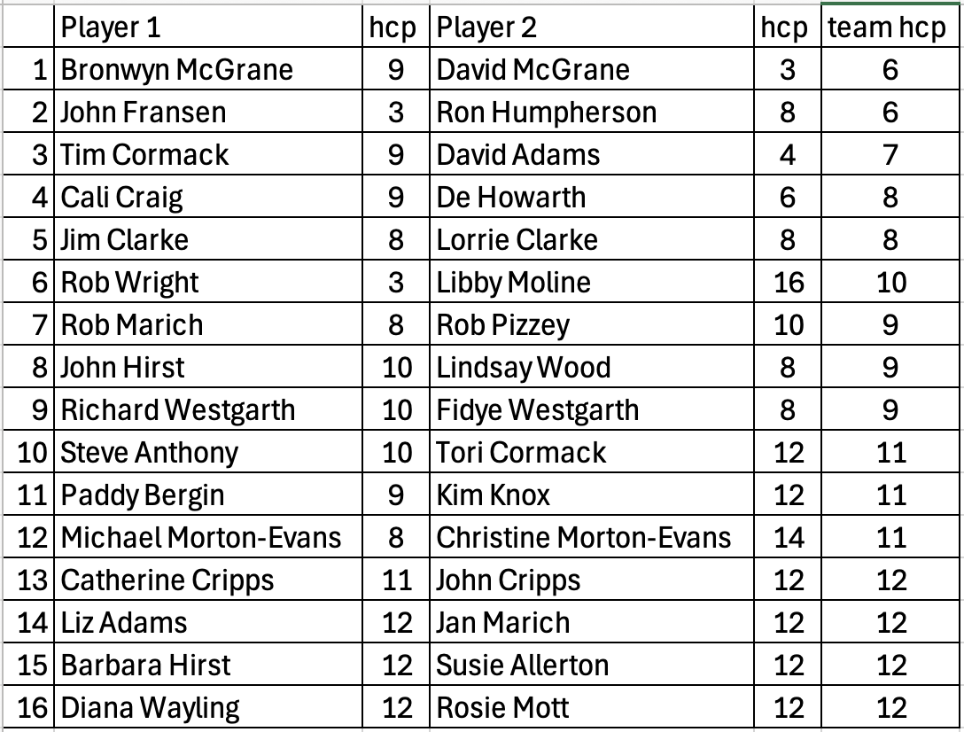
Please join Waiting Lists by entering your names and handicaps on the Reserve Entry Sheet in the clubhouse.

