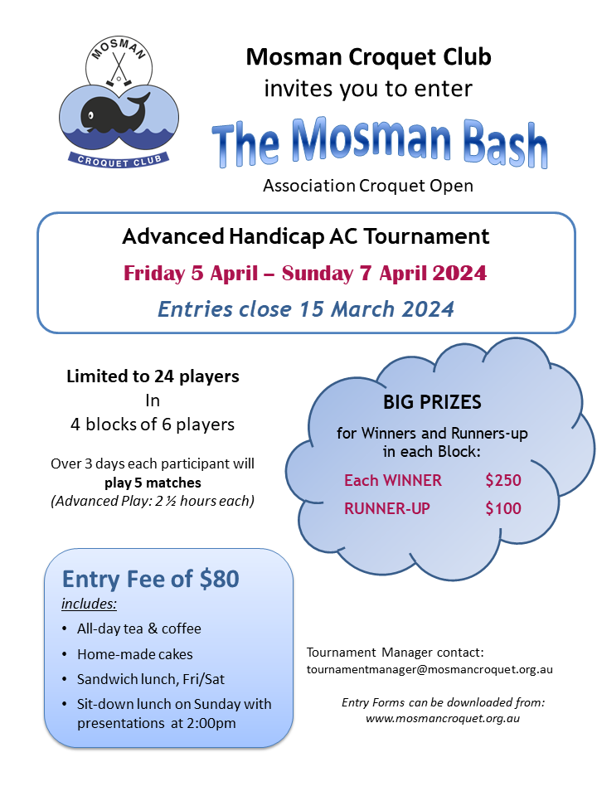

ENTRY FORM
THE MOSMAN BASH for ASSOCIATION CROQUET
Friday 5 Apr – Sunday 7 Apr 2024
Entries close 15 March 2024

PLAYER Information:
Name: [Type here]
Club: | Handicap: |  |  | Refereeing?: Yes No
Home Phone: |  |  | Mobile:
E-mail:
Please advise if any dietary requirements:

FEES:
Entry fee includes: all day tea/coffee and cakes, sandwich lunch Fri/Sat, wind-up lunch on Sunday. Visitors welcome for Sunday lunch: Cost $20/visitor
Entry fee: |  |  |  |  | $80.00
Visitor’s Sunday lunch @ $20 |  | No of visitors |  |  | $
TOTAL: |  |  |  |  | $

PAYMENT INFORMATION:
Preferably: Pay Online: OR Post Cheque:

Preferably pay by direct deposit  PLEASE NOTE NEW BANKING DETAILS:  Bendigo Bank Mosman  BSB: 633-000  Account No. 146453774  Reference: BASH “your name”  PLEASE send a copy of Entry Form by email to: tournamentmanager@mosmancroquet.org.au |  |  | Write your cheque payable to:  Mosman Croquet Club.  Send with Entry Form to:  Tournament Manager,  The Mosman Bash  Mosman Croquet Club,  2D Alexander Ave, MOSMAN, 2088

For more information:

Tournament Manager Telephone: 0412 212 228

Mosman Croquet Club Website: www.mosmancroquet.org.au

