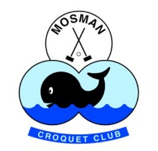NEWSLETTER

**MARCH 2022**

**OPENING OF 2022 MOSMAN CROQUET SEASON**

**Saturday 5 March 11.00 am – 3.00 pm**

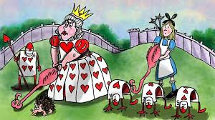

Come and join in the fun with GC doubles, 7 hoop games with prizes.

BBQ lunch $10 pp   BYO refreshments.

RSVP: Acceptance sheet in clubhouse and payment by direct debit Bendigo Bank  BSB 123123   A/C No: 146453774 and/or cash in envelope in club.

Please add your surname as reference with payment.

**LAWNS 1 & 2 BOUNDARY UPDATE FROM SUBCOMMITTEE**

In the February newsletter we advised that we now have a geo tech’s report and a revised engineering report taking into account the geo tech and our latest thinking to deal with the issues of Lawns 1-2 boundaries.

The Committee, at its meeting on February 11, considered a report from the subcommittee on the boundary issues and approved the following:

1. Remove privet hedges on all boundaries
2. Plant Japanese Buxus hedging.
3. Install a 1.1 metre fence for vital safety reasons.
4. Given proximity of new fencing to lawns push the lawns and southern shed 0.5m south.

The Lawn 1 project is being undertaken with the assistance of a State Government Grant.

The Lawn 2 project will be similar in design and will be undertaken after the completion of the Lawn 1 project, again with a State Government Grant but with greater time factors.

A contract for removal of hedges and planting for Lawn 1 has now been entered into with a landscape contractor.

Discussions are well in progress with a fencer and a builder for the other parts of Lawn 1 project.

The committee will seek an extension of the CBP20 grant deadlines given the change in the project details, Covid and weather difficulties.

**VOLUNTEERS WANTED!**

Volunteers are the only way that Mosman Croquet Club exists. At the moment, we need volunteers to assist:

The Grounds Team – Greg and his team need MORE help, particularly when it comes to competitions.

Gardening – all interested gardeners – how about giving us an hour or two a month to help with weeding etc., etc.,

Golf Croquet – Volunteers are required to co-ordinate players for Wednesdays, Fridays for GC and Social Saturdays. These days are done on a roster system so it would only be once every 4 – 6 weeks.

If can help, please contact Penny Paterson at [info@mosmancroquet.og.au](mailto:info@mosmancroquet.og.au)

**SPONSORS WANTED**

MCC is looking for new sponsors for some of its Annual Tournaments. Do any members know any businesses that would be interested in sponsoring one of our annual tournaments? If so, could you please provide details to Penny Paterson at [info@mosmancroquet.org.au](mailto:info@mosmancroquet.org.au).

**GENERAL UPDATES**

**Covid update:** No QR Code sign in is required but we do ask all members sign the attendance book each time they arrive to play croquet.

**The New Lawn Booking System**

If you are using a link to the old booking system, please delete this as it is now closed.

There is a new lawn booking system. To access it click on the button Lawn Booking System on the Home page of the club website. This will take you to an Instruction page with a link to the system. You will then be asked to login. The login is the same one you use to login to the club website. If you do not have a website login you will need to go to the website, click on Member Login and then Signup.

At present members can only book for competition play. However, it is useful for members to look at to see what lawns are available and if there are any competition matches or events taking place. If you have any queries or require assistance, please contact Penny Paterson at [info@mosmancroquet.org.au](mailto:info@mosmancroquet.org.au).

**Name Badges** – If you require a name badge, please contact Michael Chambers at [emailthedoc@yahoo.com](mailto:emailthedoc@yahoo.com)

**Membership lists** – from a security/privacy point of view, these will now no longer be emailed to members but details of all members can be found on the website under Members Only. You require a login to access this area which has lots of other useful information about club business.

**Mosman House**

Last Friday 15 ladies from Mosman House were invited to an afternoon of croquet and dinner supplied by Two Good Catering that shares love and respect through good food and for every meal purchased, an identical one goes to a women’s refuge for domestic violence survivors. The ladies were amazing and as a going home gift were each given a box of luxury care products.

Janet, Catherine Cripps and Cali were humbled by the afternoon with these survivors.

The event was funded by a local community Grant we received last year (thank you Mary and Fidye)

An afternoon BBQ is also being arranged for the ladies before the end of daylight saving.

**Mal Russell** - All members of our club will be missing Mal Russell who has been an active member of the club since joining on the 22nd March 1995. In that time Mal has twice won the Edith Wimble Trophy. The first as a new player in 1996 with E. McMillan and again in 2006 with J. Milthorpe. Some years ago, Mal was the designer of the Whale on the club flag. Mal, was a regular player of AC in all that time. Always first at the club to raise the flag, feed the Kookaburras and welcome other members. For many years his player of choice was Warren Porter and of late Lesley Fransen. With his health declining Mal’s Sister Alisa and Brother in-law Dick decided to place him in a new home at the Marcus Loane House, Macpherson Street, Warriewood. We are told he is very happy making new friends and eating well, putting back on some of the weight, he has lost in recent times. A man born on the 11th of the 11th a suitable day for a friend who will be remembered and missed by us all. From time to time we may call out to say hello.

Mary Gibson has kindly purchased a very large card to send to Mal from us all to say goodbye which is in the clubhouse so please write a few words to say g’day.

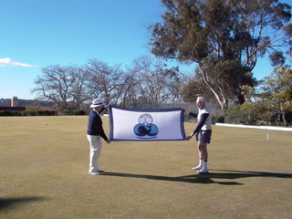 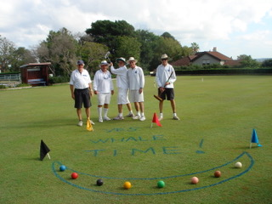

**VALE Rupert Wright** – For those who perhaps haven’t heard, Rupert passed away a short time ago. Rupert’s daughter Prue contacted Cali Craig recently with the sad news. Rupert or Robert as he was known, was a gentleman to the end and many of our members will remember him fondly. Cali has purchased a silver foliaged red flowering Grevillia which will be plant in the garden in his memory.

**COACHING**

Our sessions each Monday till April are booked out, but as cancellations do arise, please let Michael Chambers know if still interested.

February 28 Intermediate skills with Alison

March 7 Basic skills and drills with several coaches

March 14 Intermediate tactics with Alison

March 21 Basic tactics with Rob Wright

March 28 Advanced tactics with Alison

April 4 Basic skills and drills with several coaches.

And, coming up later…

* Brush up on your basic skills
* Using AC shots in GC
* Introduction to Aussie croquet / Ricochet

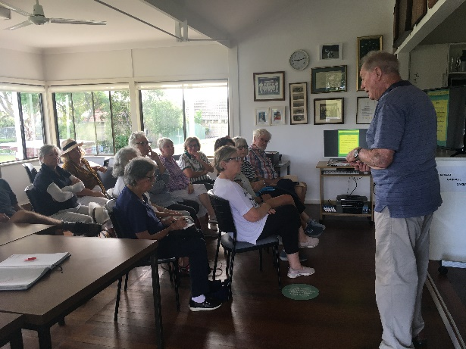 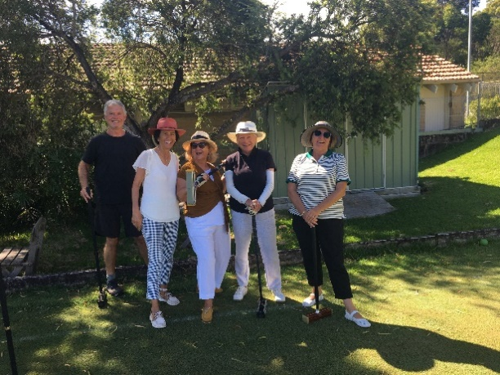

“Back to the Classroom” at the” how to use free turns” coaching session

**GC UPDATE**

2021 PENNANTS FINALS UPDATE – Unfortunately Mosman bowed out of the Pennants Finals in both Division 1 and Division 2 even though they put up a gallant fight. Canberra proved too much for all of us winning Division 1, Division 2 and Division 3. Next time hopefully we can say the same for Mosman. In any event, well done Mosman for getting to the finals.

2022 PENNANTS STARTING – Entries for this year’s Division 2 and 3 pennants have closed and Mosman has 2 teams in each, with “Tests” against other clubs starting shortly. In a break from the past our Games Committee has decided to build on last year’s fine performance by focusing on a small group of players (6 per team) to develop a strong team spirit. All players are experienced so let’s see what we can do. Captains are Helen Collins (2 Blue), TBA (2 White), Joanne Nimmons (3 Blue) and Heather Sherlock (3 White).

MEM CHALLENGE – A great and challenging two days of intense Golf Croquet. Congratulations to all those who competed and to Joanne Nimmons and Patricia Petterson for making the semi-finals. Manly won the trophy but there is always a next time. A big thank you to Elanora and Michael for designing the trophy (which is brilliant) and for donating it for the competition.

GIBSON TROPHY – Also starting on 1st March is our new club handicap championship for GC. It is a round robin event with four blocks of 8 players each, followed in June by a knockout finals event between the winners and runners-up of each block. It should be an interesting event and will be guaranteed to produce some surprises from the wide range of players. We are sure that Mary and Robert Gibson will be pleased with the outcome.

GC TOP 10 – And thanks for the February rains, El Nino! Play continues despite it, and we are making some progress. With one third of the games played we will now be under some pressure over the next month. Michael Chang is still leading after winning 4 of his five games played so far. He is followed by Rob Wright who has won 3 of his six games but only lost the others by 1 or 2 hoops. If you want to follow these games or your favourite player, results are on the MCC website very quickly.

**AC UPDATE**

**RICOCHET/AUSSIE CROQUET**

Following an incredible effort on her part, Rosalie Portus managed to persuade over 25 members of the Club to attend a ricochet session on Saturday morning, 19 February.

Ron Humpherson very kindly agreed to act as teacher, motivator and general adviser on the game of Ricochet, together with its variant, Aussie Ricochet.

Ron explained the rules of the game to the excited audience and then he and the other coaches (John Franzen, Fidye Westgarth, David MCGrane and Graham Lockhart) gave a live demonstration on the lawn.

We then broke up into different teams and played an actual game guided by our various coaches.Great fun was had by all and the decision was made to continue playing on Saturday mornings for all those interested members.

A huge thank you to Ron and the coaches for their sage advice and mentoring. A special thanks to Rosie for organising the event. A couple of photos taken by Fyde are attached to highlight the event. Fidye has also set up on the Club website the instructions for starting to play Ricochet (the simpler version, called Aussie Croquet).

Here is the link to the instructions area of the Club website:

<https://www.mosmancroquet.org.au/hints-tips-useful-links>

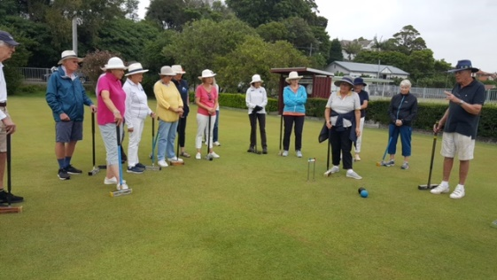 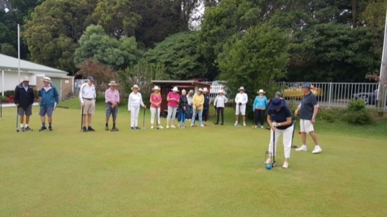

Anyone for AC? (Rob Wright)

In my last missive I described the similarities between Golf Croquet and Association Croquet. Now it’s time to describe the differences between the games.

I believe there are only two basic differences between both games – but what differences they are!

The first difference concerns hoop running. With GC only one of the four balls need to run hoop 1 before all four balls head to the following hoops, with the first ball through for each succeeding hoop getting the prize.

In AC, only the ball that runs hoop 1 can proceed to the following hoops. The other three balls remain attempting to run the hoop before they can move onto hoop 2. And this rule about each ball needing to run every hoop, remains throughout the game.

As the AC game progresses, it can get quite demanding to know which is the next hoop for each ball. Fortunately, each ball has its own-coloured clip which is placed onto the hoop that is the next in line for a hoop to be run.

As in GC, the winner of the AC game is the side which has run most hoops and scored most points.

The other basic difference between GC and AC is about when your turn ends. In GC, you strike your ball, your turn ends, and the next player then has their turn at striking their ball.

In AC, you can have up to seven strokes in your turn to strike your ball through a hoop and thus score a point. If you do strike your ball through a hoop, you can then have up to another seven strokes to run your next hoop without your turn ending. For your turn to end and having your opposing player to commence their turn, you must do something that causes it to end – common causes are not hitting your target (which, for three of those seven strokes, is another ball) or striking your ball so that it crosses the lawn’s boundary and runs off the court.

So how do you play those seven strokes? In the upcoming Introduction to Association Croquet coaching class and in my next missive I will explain the rule of how you use your seven strokes to run a hoop.

Members who may be interested in trialing the AC game, please contact Alison Sharpe (our Club Captain who is also acknowledged by the top echelon of AC players around the country as being the leading women’s AC coach in Australia!), Ron Humpherson (long standing Games Captain and current Vice-President of our club) or myself (an ex-Committee person and Club Treasurer and occasional AC and GC coach)

**MAHJONG**

Mahjong is back again – Wednesdays from 11.00/11.30 am – Anyone interested, just turn up and join the fun.

**UP AND COMING COMPETITIONS**

Have a look at Mosman Croquet’s website – we have a few Club Competitions coming up and for those interested in a couple of days away, look at the CNSW website and see what’s coming up – eg Maitland, Forster, Taree, Urunga and closer to home - Manly Seabreeze!